Name =thanjavuru Sumanth class =sy 6 roll no. =58

Problem adding two number

Code

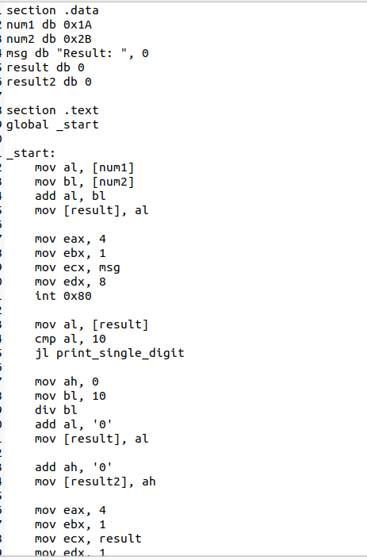

Output

